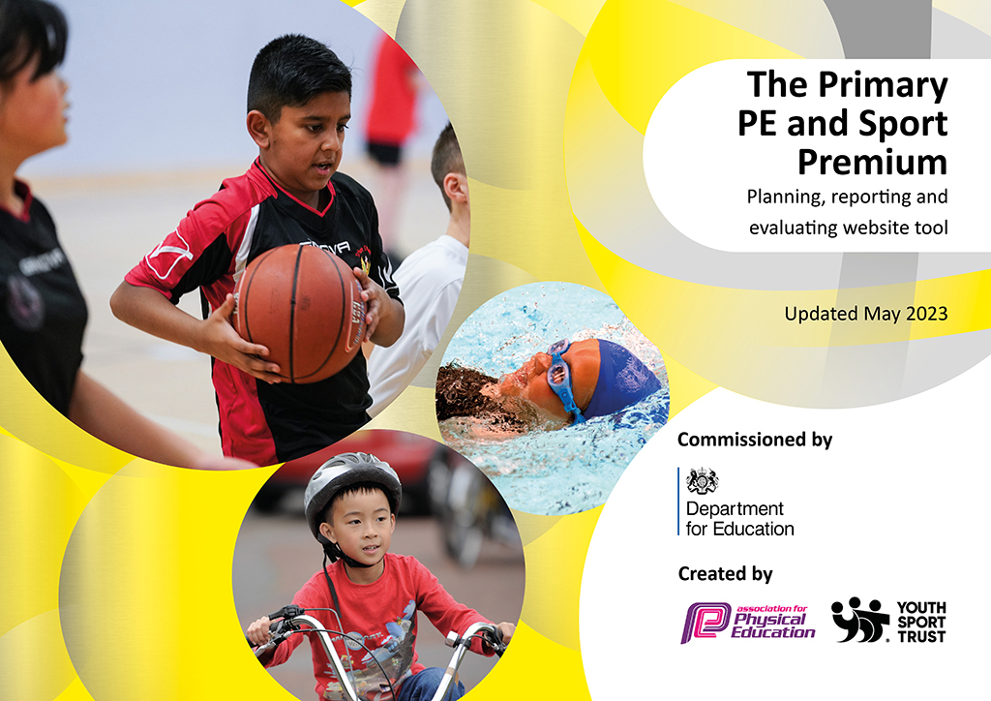
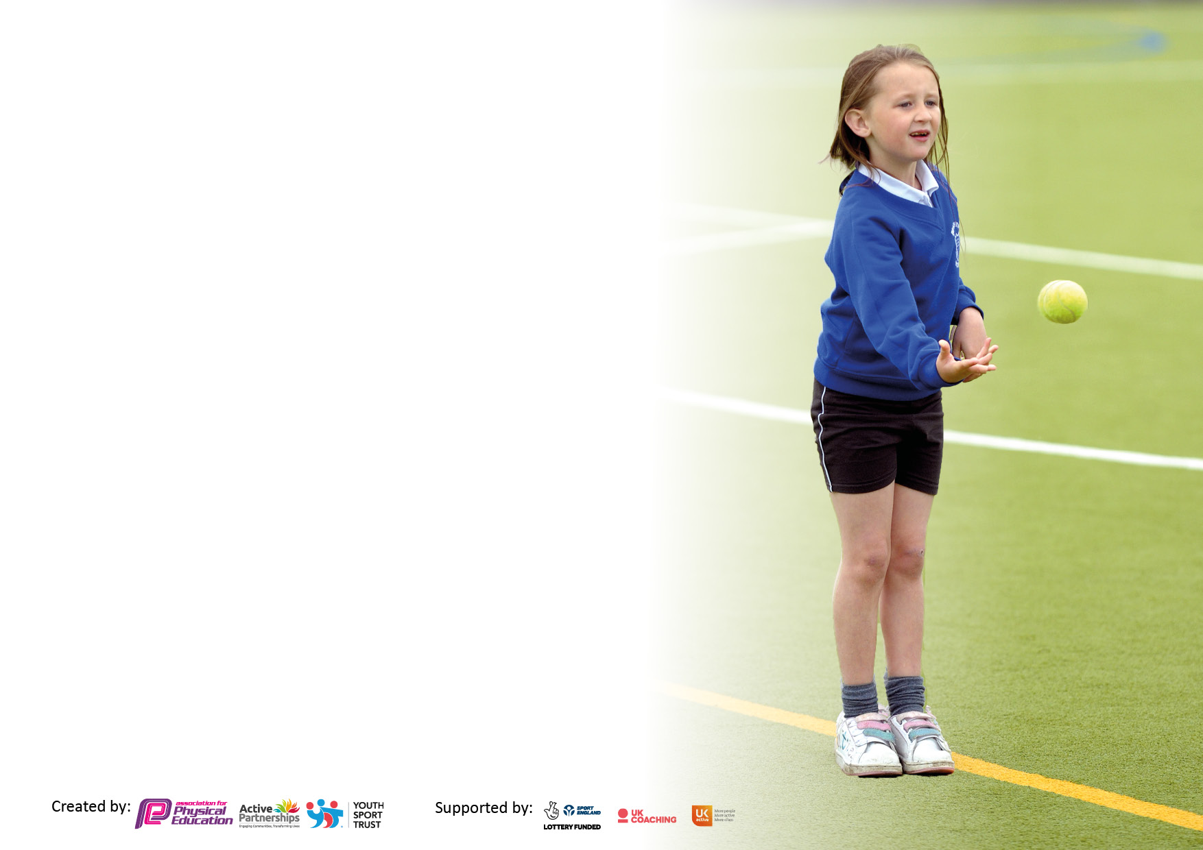

It is important that your grant is used effectively and based on school need. The Education Inspection Framework makes clear there will be a focus on ‘whether leaders and those responsible for governors all understand their respective roles and perform these in a way that enhances the effectiveness of the school’.

Under the Quality of Education Ofsted inspectors consider:
Intent - Curriculum design, coverage and appropriateness
Implementation - Curriculum delivery, Teaching (pedagogy) and Assessment
Impact - Attainment and progress

To assist schools with common transferable language this template has been developed to utilise the same three headings which should make your plans easily transferable between working documents.

Schools must use the funding to make additional and sustainable improvements to the quality of Physical Education, School Sport and Physical Activity (PESSPA) they offer. This means that you should use the Primary PE and sport premium to:

- Develop or add to the PESSPA activities that your school already offer
- Build capacity and capability within the school to ensure that improvements made now will benefit pupils joining the school in future years
- The Primary PE and sport premium should not be used to fund capital spend projects; the school’s budget should fund these.

Pleasevisitgov.ukfortherevisedDfEguidanceincludingthe5keyindicatorsacrosswhichschoolsshoulddemonstrate animprovement.Thisdocumentwillhelpyoutoreviewyourprovisionandtoreportyourspend.DfEencouragesschools to use this template as an effective way of meeting the reporting requirements of the Primary PE and Sport Premium.

We recommend you start by reflecting on the impact of current provision and reviewing the previous spend.

Schools are required to publish details of how they spend this funding, including any under-spend from 2021/2022, as well as on the impact it has on pupils’ PE and sport participation and attainment. All funding must be spent by 31st July 2023.

We recommend regularly updating the table and publishing it on your website throughout the year. This evidences your ongoing self-evaluation of how you are using the funding to secure maximum, sustainable impact. Final copy must be posted on your website by the end of the academic year and no later than the 31st July 2023. To see an example of how to complete the table please click HERE.

Details with regard to funding
Please complete the table below.

Total amount carried over from 2021/22 | £0
Total amount allocated for 2021/22 | £17,820
How much (if any) do you intend to carry over from this total fund into 2022/23? | £0
Total amount allocated for 2022/23 | £17,700
Total amount of funding for 2023/23. To be spent and reported on by 31st July 2023. | £ 17,700

Action Plan and Budget Tracking
Capture your intended annual spend against the 5 key indicators. Clarify the success criteria and evidence of impact that you intend to measure to evaluate for pupils today and for the future.

Academic Year: 2022/23 | Total fund allocated: | Date Updated:
Key indicator 1: The engagement of all pupils in regular physical activity – Chief Medical Officers guidelines recommend that primary school pupils undertake at least 30 minutes of physical activity a day in school |  |  |  | Percentage of total allocation:
 |  |  |  | %
Intent | Implementation |  | Impact
Your school focus should be clear what you want the pupils to know and be able to do and about  what they need to learn and to  consolidate through practice: | Make sure your actions to achieve are linked to your intentions: | Funding allocated: | Evidence of impact: what do pupils now know and what can they now do? What has changed? | Sustainability and suggested next steps:
Develop an outstanding sporting environment. | Sports partnership deliver CPD for PE standards at the start of the year | Sports membership price £9,690 | All pupils have the same level and expectations in PE no matter what teacher is teaching them. | More learning walks performed by the PE coordinator to check the levels are being maintained
Inspire children to participate in a range of different sporting activities. | Implement and monitor Daily Mile activities.  Offer a wider range of sporting activities in line with the curriculum. | Part of sports memberships | Pupils have been exposed to more sports. Each class has also been implementing the daily mile offering more physical activity for the pupils each da. | Continue with the daily mile. Order new sporting equipment to offer new sports such as Lacrosse equipment.
Active learning workshop | Children will learn English through active learning. Active learning helps | £275 | Pupils that aren’t usually engaged in class were more engaged in learning. | Try active learning with other subjects and continue with an English workshop
Key indicator 2: The profile of PESSPA being raised across the school as a tool for whole school improvement |  |  |  | Percentage of total allocation:
 |  |  |  | %
Intent | Implementation |  | Impact
Your school focus should be clear what you want the pupils to know and be able to do and about  what they need to learn and to  consolidate through practice: | Make sure your actions to achieve are linked to your intentions: | Funding allocated: | Evidence of impact: what do pupils now know and what can they now do? What has changed?: | Sustainability and suggested next steps:
Purchase new equipment and replace any broken equipment. | Audit PE equipment, evaluate current equipment (broken, Out of date etc.) | Currently £682 | Children now have up to date equipment to use in PE. Old equipment can be use for active breaks and lunches. | Do yearly audits and update equipment when it is to old. Purchase equipment so new sports can be tried and implemented into PE
Smoothie Bike day | Children will be taught about healthy eating and get the chance to make smoothies using physical education. | £1200 | Children have a better understanding of healthy eating. Children understand the benefit of eating the correct amount of fruit and vegetables. | Get teachers feedback on how the class enjoyed the day. From the feedback we can decide if we would like to book this day in again next year.
Achieve Gold in the school games mark | We made sure that we covered all areas that were needed to gain gold school games mark. | Free | Children had a positive sporting environment. Children got to feedback on PE and events attended. | Try to attain gold school games mark again next year.

Key indicator 3: Increased confidence, knowledge and skills of all staff in teaching PE and sport |  |  |  | Percentage of total allocation:
 |  |  |  | %
Intent | Implementation |  | Impact
Your school focus should be clear | Make sure your actions to | Funding | Evidence of impact: what do | Sustainability and suggested
what you want the pupils to know | achieve are linked to your | allocated: | pupils now know and what | next steps:
and be able to do and about | intentions: |  | can they now do? What has
what they need to learn and to |  |  | changed?:
consolidate through practice:
Sports coaches and class teachers to develop a team-teaching approach | Monitor team teaching allowing sports coaches to develop their skill sets.  Share staff areas of strengths and skills.  Ensure that all sports coaches and teachers follow a set expectation for ‘Learning intension’s’ including a skill based ‘success criteria’ and high level of challenge for all pupils.  Ensure that L.O/S.C/Challenge are always displayed.  Review assessment for daily lessons. | Included in sports Partnership membership | Pupils remember the LO’s and SC’s of the lesson. Pupils can demonstrate their learning and show improvement from the start of a lesson to the end. Teachers are more confident in delivering PE. | Continue with the team teaching approach with extra emphasis on the weak areas for the teacher.
Key indicator 4: Broader experience of a range of sports and activities offered to all pupils |  |  |  | Percentage of total allocation:
Intent | Implementation |  | Impact
Your school focus should be clear | Make sure your actions to | Funding | Evidence of impact: what do | Sustainability and suggested
what you want the pupils to know | achieve are linked to your | allocated: | pupils now know and what | next steps:
and be able to do and about | intentions: |  | can they now do? What has
what they need to learn and to |  |  | changed?:
consolidate through practice:
Attend different sporting events not just the classic sports. | We attended a badminton, climbing cricket and tennis event. We also had a day where we tried old sports such as Fencing and Archery. | Part of Sports membership | Pupils got to experience some sports they hadn’t tried before. Childrens knowledge of different sports has increased. | Continue to attend a variety of sporting events. Buy equipment for new sports.
Sporting opportunities for PP | We paid for PP children to experience some different sporting opportunities. These included a Climbing event and PGL. | £1,578 | PP pupils got to experience sporting events they would not of normally got the opportunity for. PP children got to experience a range of sports. | Look at other sporting opportunities that we could look to pay for.
Sport workshops and league memberships | HotShotz tennis came and ran a tennis event for all the classes. Maude sports Olympic athlete visit to inspire children to try kickboxing and other Olympic sports. Football league membership to allow us to play against other schools. | £50 | Children were exposed to new sports. They all got the chance to engage with the sports. | Continue to get workshops in to expose the children to a range of sports.

Key indicator 5: Increased participation in competitive sport |  |  |  | Percentage of total allocation:
 |  |  |  | %
Intent | Implementation |  | Impact
Your school focus should be clear | Make sure your actions to | Funding | Evidence of impact: what do | Sustainability and suggested
what you want the pupils to know | achieve are linked to your | allocated: | pupils now know and what | next steps:
and be able to do and about | intentions: |  | can they now do? What has
what they need to learn and to |  |  | changed?:
consolidate through practice:
Attend and compete in a wider range of sporting events/tournaments. | Attend all sporting events that we can make it to. Track who goes to sporting events so we can pick different pupils for the next event. Pay staff overtime to allow us to attend more sports events. | £133 | Pupils got to experience competition against other schools. They got used to winning and losing. Pupils can deal with both winning and losing better now they have experienced it more. | Continue tracking who goes to events and try to get every child to at least 1 event in the academic year.

Signed off by
Head Teacher: | Isabel Ramsey
Date: | July 23
Subject Leader: | Danny Miles
Date: | July 23
Governor: | Jamie Ross
Date: | Sep 23

